# Travel

# Created on August 02 2019

# Table of Contents

1.0. Reservation

2.0. Login page

3.0. Contact page

4.0. HOME

# 1.0. Reservation

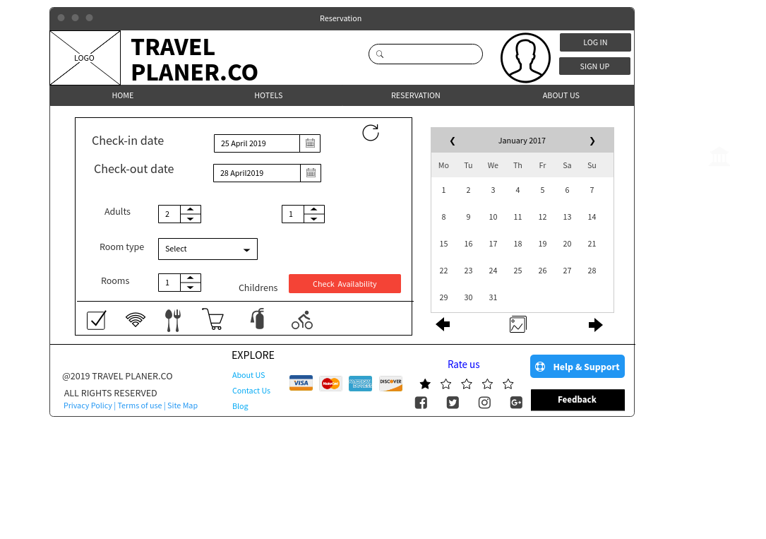

# 2.0. Login page



# 3.0. Contact page

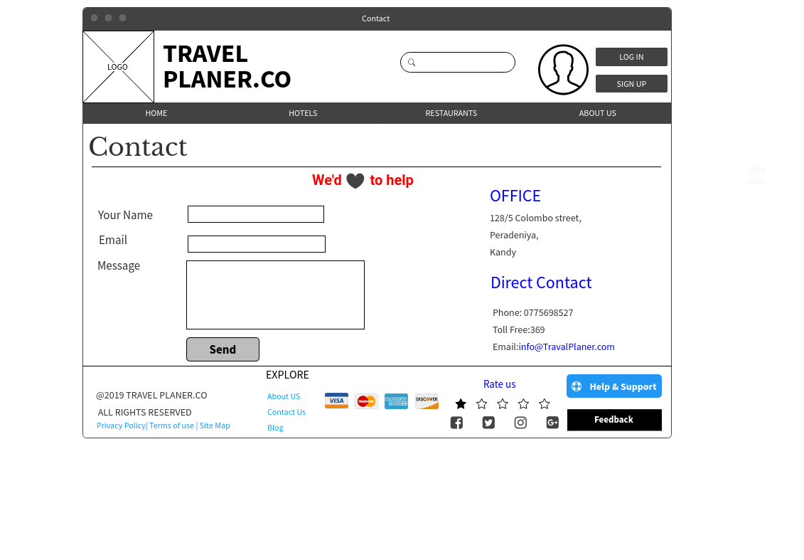

# 4.0. HOME

